
Name: …………….…….......……
Resource Free | /30 | %
Resource Rich | /27 | %
Total | /57 | %

Mathematics Methods, Year 12, 2018
Test 1 – Further differentiation and applications

30 minutes working time.
Calculator Free Section (no notes, no calculators)
SCSA Formula sheet allowed

1. [6 marks: 2, 2, 2]
Determine for each of the following.

a) $f\left(x\right)=\sqrt{2x}-\frac{3}{x}$

b) $f\left(x\right)=\frac{x-2}{x+1}, x≠-1$

c) $y=\sqrt{3x+2}$

2. [3 marks]
Use $y=\sqrt{3x}$ and $y=x^{\frac{3}{2}}$to comment on whether the derivative of the product of two functions is equal to the product of their derivatives.

3. [3 marks]

If $y=xf^{'}\left(x\right)$, show that $\frac{d^{2}y}{dx^{2}}=xf^{'''}\left(x\right)+2f''(x)$.

4. [4 marks]

Calculate the minimum and maximum values of $x^{2}(6-x)$ in the interval $1≤x≤5$.

5. [2 marks]
A particle leaves the origin when $t=1$ and moves in a straight line with velocity at any time $t$ seconds, where $t≥1$, given by
${v\left(t\right)= \frac{t^{2}}{4}+\frac{4}{t}-\frac{7}{4} ms}^{-1}$
Determine the time when the acceleration of the particle is zero.

6. [5 marks]
Given that $y=\sqrt{x}$ , use $x=100$and the incremental formula $δy=\frac{dy}{dx}×δx$ to determine an approximate value for $\sqrt{104}$.

7. [7 marks: 1, 1, 1, 1, 3]
Given ,

a) Evaluate:

(i) f (2)

(ii) f ′(2)

(iii) f ′′(2)

b) i. Sketch the graph of f (x) over the domain on the axes provided.
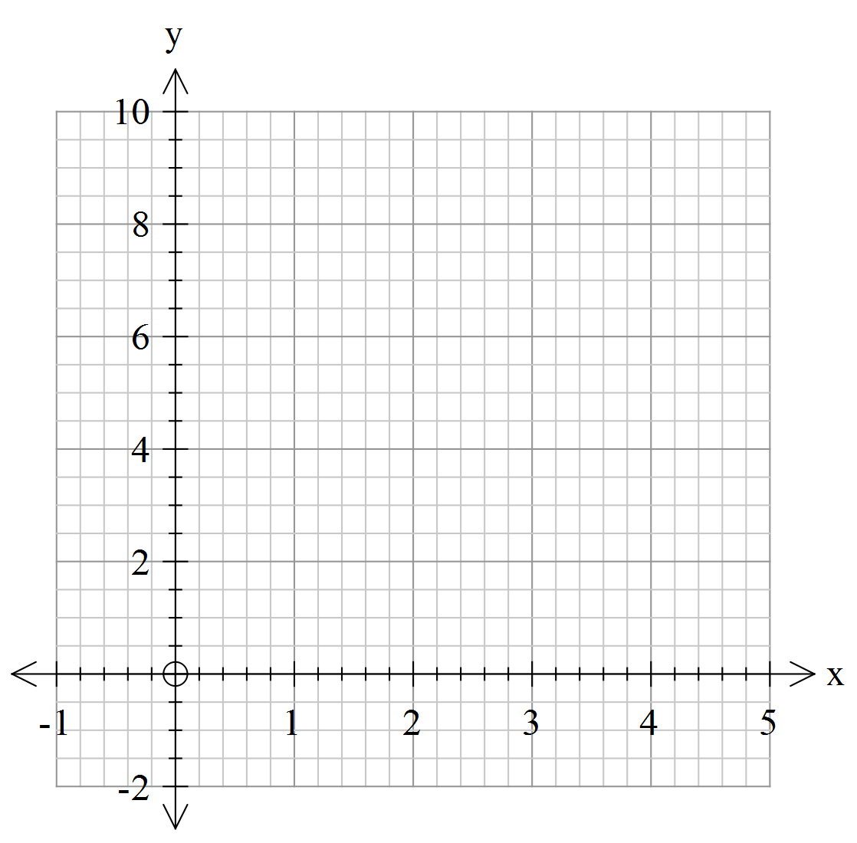

ii. With reference to your sketch, explain the significance of each answer from part a.

END OF CALCULATOR FREE SECTION

